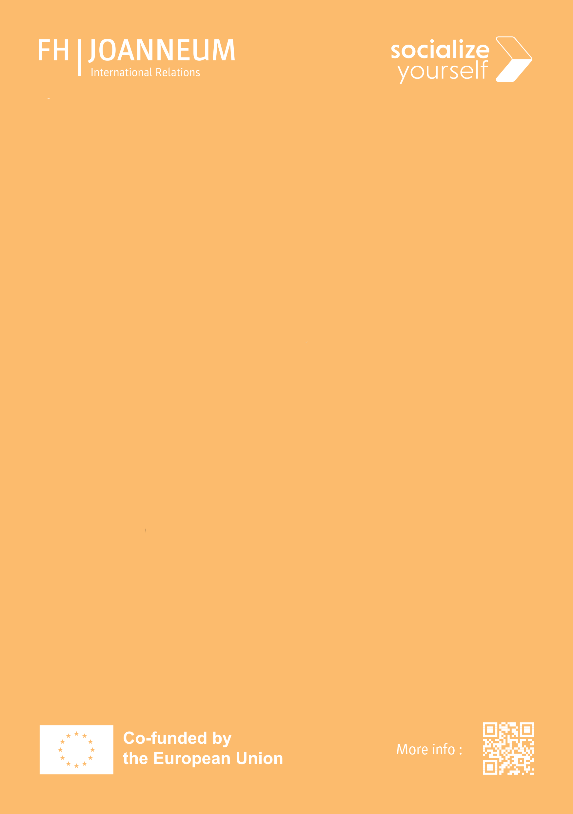**INTERNATIONAL EVENTS**

**WINTER SEMESTER 2025**

**OCTOBER**

**15** | 1200 - 1500 Erasmus+ Day @EA11

**16** | 1945 Tandem Café – *Get to know your Tandem partner(s)* @EA11.001*

**20 |** 1830 Getting to know the “Stadtteilzentrum” @GRAZ

**21** | 1800 Cultural Diversity – *Weltreise im Hörsaal* @EA11.001

**23** | 1630 Diversophy @EA11.454

**28** | 1630 Jodl Workshop - *Learn the basics of yodeling* @EA11.128

**NOVEMBER**

**04** | 1800 Cultural Diversity – *Weltreise im Hörsaal* @EA11.001

**13** | 1630 Diversophy @EA11.454

**18** | 1800 Cultural Diversity – *Weltreise im Hörsaal* @EA11.001

**25** | 1630 Guided Christmas Walk – *Welcome to winter wonder Lend* @GRAZ

**DECEMBER**

**01** – **15** | Christmas Cookie Challenge

**02** | 1800 Cultural Diversity – *Weltreise im Hörsaal* @EA11.001

**03** | 1200 - 1500 International Fair @AUDIMAX

**09** | 1700 Tandem Cooking @EA11.312*

**16** | 1800 Cultural Diversity – *Weltreise im Hörsaal* @EA11.001

**JANUARY**

**13** | 1800 Cultural Diversity – *Weltreise im Hörsaal* @EA11.001

**20** | 1630 Goodbye Event / End of Semester Event

**29** | 1800 Tandem Presentations @EA11.458

**\*for Tandem Programme Participants only**